

NodeJS

Semester: 3 |  | Curriculum Code: 7023
Duration: 90 minutes |  | Total Marks: 20

Practical Examination Paper

I – Create API with NodeJS
1. Create database ManaEmployee in MySQL:
- Have two tables: 1 point
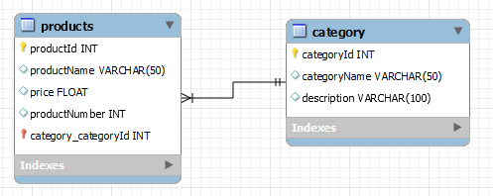
- Insert some data into products and category tables. - 1 point
2. Use the NodeJS and Express + MVC for create API project with some functions:
2.1 Create Controller API: CATEGORY with method Get (get all category), Post (Insert category), Put (Update category), Delete (Delete category by id). - 3 points
2.2: Create Controller API: PRODUCT with method Get (get all Products), Post (Insert Product), Put (Update Product), Delete (Delete Product by id) and Search(string strsearch ) method for search PRODUCT with productName, prices and categoryName. – 4 points
3. Using Postman tool for test all API. (Take a screenshot of the postman when the test api). - 2 points
4. Public web API on the IIS (local computer - Take a screenshot of the IIS) -1 point
II. Create Website: - 8 Points
1. Using website template in the folder of the test (Vesperr.zip). Create NodeJs project, it has structure follows:
- Public
- css/scss
- img
- js
- fonts
- vendor
- Views: contain below file html
  - Index.html.
  - About.html
  - Services.html
  - Team.html
  - Pricing.html
Create router.js and main,js
2. Public website on the IIS (Take a screenshot of the IIS)

Note: Students are allowed to access IIS Manager on the local computer.

